Birch CofE Primary School Wraparound Care
Early Birds Breakfast Club
7.45am – start of school
- Choice of breakfast e.g. cereals, toast, spreads and jams, fresh fruit and fruit juice.
Teatime Tigers After School Club
3.20pm – 4.20 pm and 4.20pm – 5.20 pm (or both)
- Fresh fruit and refreshments provided 1st session.
- Fresh fruit, toast and refreshments provided 2nd session.
- Range of indoor and outdoor activities at both sessions ~ art and crafts, games and puzzles, Lego and construction toys, rainy day films on the big screen, sunny day outdoor play and fun on the field.
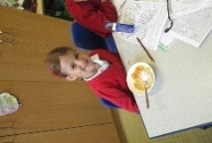
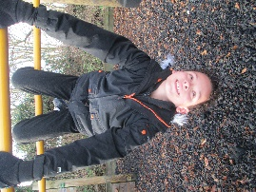
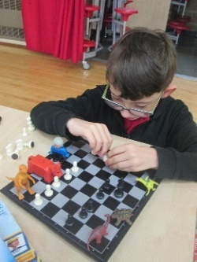

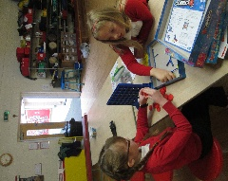

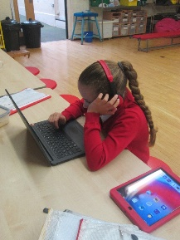
For further information, email childcare@birch.essex.sch.uk – to book a place, please use the Scopay app.
Sessions can be booked on an ad hoc or regular basis.
Have fun just ‘monkeying’ around!
Start your day the right way! Wind down at the end with lots of fun and new friends

Arrange a playdate!
Re-invent a classic!
Busy week? Do your homework or practise your spellings with us!

